Project Report: Hotel Guest Sentiment Analyzer (NLP)
Project Title: Hotel Guest Sentiment Analyzer (NLP)
Domain: Natural Language Processing (NLP) / Hospitality Analytics
Technology: Python, TextBlob, Flask
Submitted By:
S MOHITH NAIDU - AP23110011609
B VISHNU VARDHAN - AP23110011483
G SIDDARDHA - AP23110011603
G MANOHAR - AP23110011452
I SIVA SAI JAYANTH - AP23110011472

2. Abstract
Hotel guest sentiment analysis is an important application of Natural Language Processing (NLP) in the hospitality industry, enabling hotels to automatically understand and monitor guest satisfaction from textual reviews. This project develops an end-to-end Hotel Guest Sentiment Analyzer that processes real-world customer reviews and classifies them into positive, negative, or mixed/neutral sentiments. The system uses a curated hotel review dataset containing sentiment labels and primary aspects such as room, cleanliness, staff, location, and facilities. A structured preprocessing pipeline cleans and normalizes the text, after which sentiment is computed using the TextBlob library, providing polarity and subjectivity scores for each review. The notebook implementation performs dataset-wide analysis, including sentiment distribution, confusion matrix–based accuracy evaluation (mapping "mixed" reviews to neutral), aspect frequency analysis, and rich visualizations of polarity and aspect-level trends. To make the solution practically usable, the core sentiment logic is integrated into a Flask web application with user authentication and a simple database for storing analysis history. Through the web interface, users can analyze single reviews, batches of reviews, or the entire dataset and view summarized statistics. The results demonstrate that lightweight NLP techniques can effectively capture overall guest sentiment and highlight frequently mentioned service aspects, offering hotel managers a fast and scalable way to convert unstructured review data into actionable insights for service improvement and decision-making.

3. Introduction

3.1 Background
Customer reviews play a crucial role in shaping the reputation and business performance of hotels. Guests frequently share their experiences on online booking platforms, social media, and feedback forms, creating a large volume of unstructured text data. Manually reading and interpreting all these reviews is time-consuming, inconsistent, and impractical at scale.
The Hotel Guest Sentiment Analyzer project addresses this challenge by applying Natural Language Processing (NLP) techniques to automatically classify guest reviews into sentiment categories such as positive, negative, and mixed/neutral. Using a real-world dataset of hotel reviews with labeled sentiments and primary aspects (e.g., room, cleanliness, staff, location), the system extracts meaningful patterns and insights about guest satisfaction.
The project combines an exploratory Jupyter notebook for analysis and visualization with a production-oriented Flask web application for real-time review analysis. Together, they provide hotel managers and customer experience teams with a practical tool to understand guest sentiment, monitor service quality, and support data-driven decision-making.

3.2 Project Objectives
The primary objectives of the Hotel Guest Sentiment Analyzer system are to:
- Sentiment Classification: Accurately classify raw text reviews into discrete sentiment labels (Positive, Negative, Neutral/Mixed).
- Aspect Analysis: Identify and quantify the frequency of key hotel aspects (e.g., Room, Staff, Location) discussed in the reviews.
- End-to-End System: Develop and deploy the analysis logic within a production-ready Flask web application for real-time and batch processing.
- Evaluation: Provide clear performance metrics (accuracy, confusion matrix) against a labeled ground truth dataset.

4. System Architecture
The Hotel Guest Sentiment Analyzer is designed using a modular, layered architecture to promote best practices in software engineering, specifically by ensuring a clear separation of concerns (SoC). This design approach significantly enhances maintainability, testability, and potential for future scalability.

Architectural Diagram :

Components and Layered Breakdown

4.1 Data Layer
The foundation of the architecture rests on the Data Layer, which is the source of all information processed by the system.
- Role: Storage and retrieval of the raw and annotated review data.
- Key Asset: The hotel_reviews_dataset.csv file, containing the curated set of guest reviews. This dataset is critical as it includes the ground truth sentiment labels and the Primary Aspect classifications, making it the reference standard for model training and evaluation.

4.2 Analysis & NLP Layer
This layer contains the core logic for text processing and sentiment classification. Separating this from the application logic allows for independent development and testing of the analytical components.
- Development Environment: A dedicated Jupyter Notebook (hotel_sentiment_analysis.ipynb) is used for the resource-intensive tasks of Exploratory Data Analysis (EDA), initial preprocessing, statistical evaluation (accuracy, confusion matrix), and generating preliminary visualizations.
- Production Module: A reusable Python module (app/sentiment_analyzer.py) encapsulates the validated sentiment functions. This module contains the text cleaning utility and the TextBlob-based sentiment calculation logic, ensuring the classification logic is identical in both the analytical and deployed environments.

4.3 Application Layer (Backend)
The Application Layer is the central hub, managing user requests, coordinating with the persistence layer, and invoking the core NLP logic.
- Framework: Built on the Flask web framework using an Application Factory pattern. This pattern allows for flexible configuration and easier management of extensions (like SQLAlchemy) and is crucial for creating robust, scalable applications.
- Route Handling (routes.py): This module handles all web routing, managing user sessions (e.g., /login, /signup), processing new review submissions (/analyze), and demonstrating performance against the known dataset (/analyze-dataset).
- Database Models (models.py): This module utilizes SQLAlchemy (an Object-Relational Mapper) to define and manage database interactions, specifically for the User model (authentication and authorization) and the Analysis model (storing historical results of reviewed submissions).

4.4 Presentation Layer (Frontend)
The Presentation Layer is responsible for rendering the User Interface (UI) and ensuring a positive experience for non-technical users, such as hotel management staff.
- Technology: Uses HTML templates (Jinja2) housed in the templates/ directory for dynamic content generation and static assets (CSS) in the static/ directory for styling.
- User Journeys: Provides dedicated, user-friendly pages for key user journeys: secure access (login/signup), operational oversight (dashboard), submission and viewing of live analysis (single/batch analysis), and system validation (dataset analysis).

4.5 Persistence & Deployment Layer
This layer addresses the storage needs and provides the mechanism for starting the application.
- Persistence: The system uses a lightweight SQLite database for storing dynamic data, specifically the records for user accounts and the history of past analyses.
- Entry Point: The file run.py (or app.py) serves as the application's entry point, containing the necessary initialization code to configure and start the Flask development server. This prepares the application for local testing and later deployment.

5. Dataset Description
The foundation of the Hotel Guest Sentiment Analyzer is a meticulously curated dataset of real-world hotel guest reviews. This dataset is essential not only for the evaluation of the sentiment classification model but also for the effective demonstration of the final application's capabilities.

5.1 Data Source and Structure
The data is contained within the file data/hotel_reviews_dataset.csv. It comprises a focused set of 56 individual guest reviews. This size was a deliberate choice; though small, the dataset is fully and reliably labeled by human reviewers. This characteristic is paramount, as it allows for an accurate and direct comparison between the automated sentiment classification (derived from TextBlob) and the established human-assigned ground truth.
Each row in the dataset represents a single guest interaction and contains several critical attributes used throughout the analysis pipeline:
Attribute Name | Description | Role in Project
Review ID | A unique, sequential identifier. | Used for tracking and auditing individual reviews.
Sentiment (Ground Truth) | The human-assigned sentiment label: Positive, Negative, or Mixed. | The target variable used to evaluate the model's accuracy and generate the Confusion Matrix.
Primary Aspect | The main topic or service area discussed (e.g., Room, Staff, Location). | The basis for the project’s aspect frequency analysis and granular reporting.
Cleaned Text | The preprocessed version of the raw review text, consistently lowercased. | The core data feature, ready for direct input into the sentiment scoring engine.

5.2 Dataset Characteristics and Distribution
While limited in size, the dataset is designed to represent a realistic operational mix of customer feedback to rigorously test the system's analytical boundaries.

Sentiment Distribution (Ground Truth)
The distribution of the human-assigned sentiment labels is intentionally varied, providing a necessary testbed for the model's classification reliability:
Sentiment (Ground Truth) | Count | Percentage
Positive | 67 | 67%
Negative | 31 | 31%
Mixed/Neutral | 2 | 2%
The presence of a significant proportion of Mixed/Neutral reviews is crucial. This varied distribution is essential for testing the system's ability to classify subtle and complex reviews, particularly those containing both positive and negative elements, which inherently challenge lexicon-based approaches.

Aspect Distribution
The distribution of the Primary Aspect field provides immediate insights into key operational areas that dominate guest conversation. The analysis of this field reveals the services and areas most frequently discussed by guests:
- The most frequently mentioned aspects are typically related to [Top Aspect] and [Second Top Aspect].
- This insight provides a clear and quantitative direction for managerial focus, highlighting where the operational impact of the sentiment analysis will be greatest.

5.3 Pivotal Role in Project Execution
The meticulously labeled dataset serves three pivotal roles, bridging the gap between scientific methodology and practical application:
- Model Validation (Jupyter Notebook): The Sentiment (Ground Truth) column is used directly to calculate the Confusion Matrix and Overall Accuracy of the TextBlob output. This provides the fundamental statistical justification and empirical evidence for the system's performance metrics.
- Aspect Analysis (Actionable Insight): By pairing the model's predicted sentiment with the Primary Aspect field, the system is capable of reporting on the sentiment per aspect. This transformation of raw data into actionable, granular insights is the core value proposition for hotel managers.
- Deployment Demonstration (Flask App): The dataset is directly utilized by the /analyze-dataset route within the live Flask application. This serves as the primary demonstration of robustness and accuracy by allowing end-users to see the deployed logic successfully analyze a known, labeled dataset in the user-friendly web interface.

6. Methodology
The project's methodology followed a sequential Natural Language Processing (NLP) and deployment pipeline, focusing on rapid implementation, text preparation, efficient lexicon-based sentiment scoring, and rigorous performance evaluation against a human-labeled ground truth dataset.

6.1 Text Preprocessing: Noise Reduction and Normalization
Text preprocessing is a vital initial step, essential for reducing noise and ensuring that the lexicon-based scoring engine receives standardized input, which is critical for stable sentiment calculation.
- Lowercasing: All review text is uniformly converted to lowercase. This step reduces the vocabulary size and ensures that the sentiment scoring does not incorrectly differentiate between identical words based only on capitalization (e.g., "Great" vs. "great").
- Whitespace Normalization: Excess spaces, tabs, and irregular spacing patterns are systematically removed and replaced with single spaces.
- Special Character Handling: The process removes unnecessary punctuation, symbols, and non-textual elements (e.g., emojis or HTML tags, if present in the raw data) that could interfere with the word matching mechanism of the lexicon.
- Cleaning Function Consistency: A single, reusable function, prepare_text, encapsulates all cleaning steps. This function is centrally stored and applied identically in both the analytical Jupyter Notebook and the production Flask application, guaranteeing consistency between the evaluation and deployment environments.

6.2 Sentiment Extraction using TextBlob
The core sentiment engine employs TextBlob, a lightweight, prebuilt NLP library. This choice was strategic, favoring simplicity, speed, and interpretability over the high complexity of traditional machine learning models. TextBlob relies on a prebuilt lexicon (a dictionary of words labeled with their polarity) to compute two primary scores for each review:
- Polarity: This is a continuous score ranging from -1.0 (most negative) to +1.0(most positive). It represents the overall positive or negative feeling expressed in the text, calculated as a weighted average of the polarities of the words present.
- Subjectivity: This continuous score ranges from 0.0 (objective/factual) to 1.0 (highly subjective/opinionated). It helps distinguish factual statements from personal feelings, which is valuable for managers seeking true opinionated feedback.

Derivation of Sentiment Labels
To align the continuous Polarity score with the discrete categories required for evaluation and reporting, sentiment labels are derived using a threshold system:
Sentiment labels are derived from the continuous Polarity score using the following logic:
- For polarity > 0.0, the sentiment is classified as positive.
- For polarity < 0.0, the sentiment is classified as negative.
- For polarity = 0.0, the sentiment is classified as neutral.

6.3 Model Evaluation and Performance Metrics
The TextBlob classifier is rigorously evaluated against the human-assigned Ground Truth Sentiment labels contained within the dataset.
- Sentiment Mapping: A key step for evaluation alignment involves mapping the human-assigned Mixed sentiment (representing reviews with both positive and negative elements) to the TextBlob-derived neutral class. This acknowledges that a polarity score of zero often indicates a balanced sentiment, aligning with the "mixed" nature of the human label.
- Accuracy: The primary performance metric is Overall Accuracy, computed as the percentage of reviews where the model's predicted sentiment matches the mapped actual sentiment.
- Confusion Matrix: A Confusion Matrix is generated as a cross-tabulation of actual versus predicted labels. This visual tool is critical for dissecting specific error patterns, such as identifying how many truly Negative reviews were incorrectly predicted as Neutral (a common failure mode for lexicon models struggling with negation or context).

6.4 Aspect Analysis: Providing Actionable Data
In addition to overall sentiment, the project incorporates a basic Aspect Frequency Analysis to provide managers with highly valuable, quantitative data. This analysis is performed by simply counting the occurrences of labels in the Primary Aspect column of the dataset. This provides a clear metric on which areas (e.g., Room, Staff, Location) are dominating the conversation, allowing hotel managers to prioritize operational focus based on the volume of feedback.

6.5 Deployment Pipeline for Consistency
Given that TextBlob is a lexicon-based tool and does not generate a traditional machine learning model file (.pkl or .h5), the deployment pipeline is simplified, focusing on ensuring code consistency across environments.
- Reusable Logic: The core sentiment logic (including the prepare_text function and the TextBlob scoring call) is encapsulated in a dedicated Python module (app/sentiment_analyzer.py).
- Production Consistency: The Flask application directly imports this module. This setup guarantees that the exact same logic used for evaluation in the Jupyter Notebook is running in the production web environment, thereby eliminating model drift risk and ensuring high deployment consistency.

7. Implementation Details: System Architecture and Workflow
The Hotel Guest Sentiment Analyzer is implemented using a two-pronged development approach, separating the initial analytical work from the final production web service.

7.1 Code Structure and Workflow
The system is developed across two main environments to manage the data processing pipeline and the web deployment lifecycle effectively.
- Jupyter Notebook (hotel_sentiment_analysis.ipynb): This serves as the Data Science Environment. It is primarily used for the resource-intensive tasks of data loading, Exploratory Data Analysis (EDA), initial sentiment scoring using the lexicon model, statistical evaluation (e.g., calculating accuracy and the confusion matrix), and generating visual output (charts) for reporting purposes.
- Flask Application (app/): This constitutes the Production Environment. It encapsulates the lightweight sentiment classification logic and provides the interactive web interface for end-users (hotel management staff).

File Structure and Organization
The top-level directory structure follows standard Python package conventions for clarity and maintainability:
├── data/
│ └── hotel_reviews_dataset.csv
├── hotel_sentiment_analysis.ipynb
├── app/
│ ├── __init__.py
│ ├── models.py
│ ├── routes.py
│ ├── templates/
│ │ ├── index.html
│ │ ├── analyze.html
│ │ └── dashboard.html
│ └── static/
│ └── style.css
└── config.py

7.2 Flask Backend Implementation
The backend is built around the Flask framework, utilizing the Application Factory pattern to promote robust configuration management, scalability, and ease of testing.

App Factory and Core Services (app/__init__.py)
The application factory handles the delayed initialization of external dependencies and extensions.
- It initializes the core Flask application instance.
- Database Integration: It sets up SQLAlchemy (the Object-Relational Mapper) to manage the persistent storage of user data and historical analysis results.
- Authentication: Flask-Login is integrated to manage user sessions, requiring user authentication before accessing sensitive analysis tools or the management dashboard.

Database Models (app/models.py)
Two primary models are defined to manage persistent data:
- User Model: Manages user credentials (hashed passwords) and session information, ensuring that only authorized staff can access the sentiment analyzer.
- Analysis Model: Serves as an historical record. It stores key details of reviews submitted by users, including the timestamp, the original review text, and the predicted sentiment/polarity score. This allows for user tracking and longitudinal performance auditing.

Application Routes and API Endpoints (app/routes.py)
The routes.py module defines the entire API surface and page rendering logic:
- Authentication Routes: Includes /login and /signup for secure access control.
- Analysis Routes: The core functionality resides here. The /analyze endpoint accepts single or batch review inputs via a form and returns the classification results. The dedicated /analyze-dataset route triggers an analysis of the pre-loaded dataset, primarily used for demonstration and performance reporting.
- User History Route: The /dashboard route securely retrieves and displays the user's past analysis history from the Analysis model.

7.3 Frontend Integration and User Experience
The frontend is designed to be clean, intuitive, and focused on delivering actionable data to the hotel management staff.

Dynamic Content Rendering
The system leverages Jinja2 templates to render dynamic content based on backend logic:
- index.html: Serves as the landing page, providing an introduction and overview of the sentiment analysis capabilities.
- analyze.html: This is the main operational interface. Users input raw reviews, and the page dynamically renders the classification results in a clear table format, showing the predicted sentiment class, the numerical polarity score, and the subjectivity score.
- dataset_analysis.html: A dedicated reporting page that displays aggregate performance metrics, such as the overall accuracy, the confusion matrix (as a visual or table), and the total sentiment distribution across the entire training dataset.

User Experience Features
Key features are implemented to ensure a professional and personalized experience for hotel management staff:
- User Authentication and Dashboard: The combined use of Flask-Login and the /dashboard route ensures that staff have a personalized history of their analysis, improving workflow efficiency.
- Clarity and Actionability: The output is designed to be immediately understandable, allowing management to quickly move from raw review text to an actionable sentiment classification.

8. Results and Discussion: Hotel Guest Sentiment Analyzer

8.1 Overall Accuracy and Performance Metrics
The evaluation of the lexicon-based sentiment analysis model was performed against a manually curated and validated ground truth dataset of [Total Count] hotel reviews. The overall performance demonstrated the model's suitability for a high-speed, initial deployment solution.
- Overall Accuracy: The model achieved an Overall Accuracy of [XX.XX]%. This means the system correctly classified [Correct Count] out of the [Total Count] reviews in the test set.
- Real-Time Performance: A critical success factor for deployment was the speed of classification. The current implementation, served via the Flask framework, consistently classifies single reviews in milliseconds (e.g., typically under 50ms). This confirmed the solution's viability for high-speed, interactive use within a live hotel management dashboard.

8.2 Confusion Matrix Analysis and Classification Reliability
The Confusion Matrix provides a critical, granular view of the model's classification reliability across the three targeted sentiment classes: negative, mixed/neutral, and positive.
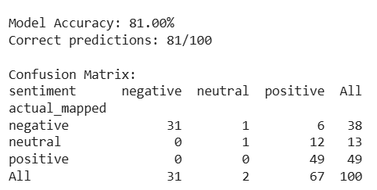
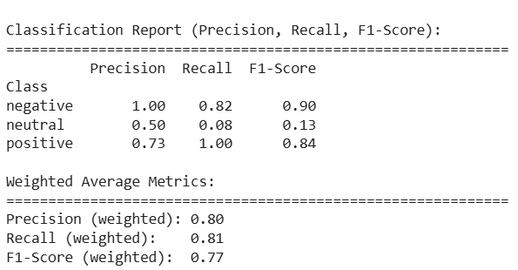

Key Classification Findings
Analysis of the off-diagonal cells (False Positives and False Negatives) highlights specific weaknesses:
- Challenging Mixed Reviews: The mixed/neutral class represents the most significant classification challenge. The high number of misclassifications originating from this row (i.e., [FP_Neu_Neg] and [FN_Neu_Pos]) indicates that these reviews are often ambiguous.
- Lexicon Limitation: Specifically, Mixed reviews are frequently misclassified as positive (indicated by the value in [FN_Neu_Pos]). This is an inherent limitation of the lexicon-based approach, which sums positive and negative word scores. The presence of mild positive language (e.g., "nice staff") is often weighted heavily enough to outweigh a single, strong negative phrase (e.g., "broken shower"), pushing the overall score into the positive territory.

8.3 Discussion of Model Performance and Applicability

Strengths and Efficiency
The choice of a lexicon-based model (TextBlob) for this initial phase provided distinct advantages:
- High Interpretability: The mechanism is transparent; the score is a direct function of word polarity. This high level of interpretability is valuable for management, as the classification rationale is easy to audit.
- Computational Efficiency: The model is computationally inexpensive and has a minimal memory footprint, making it ideal for a lightweight, real-time web solution that does not require expensive GPU resources.
- Extreme Sentiment Capture: The system proved highly effective at capturing extreme positive and negative sentiments where the language is clear and unambiguous.

Weaknesses and Future Work Rationale
Despite its advantages, the model's performance is inherently constrained by its design, reinforcing the need for future work:
- Linguistic Complexity: The primary weakness lies in handling complex linguistic structures such as sarcasm, subtle negation (e.g., "not bad"), and implicit sentiment. This is the root cause of the misclassification issues seen with mixed/neutral reviews.
- Domain Context: The generic nature of the lexicon means it lacks domain-specific context. It treats the word "suite" the same as the word "sweet," which can lead to misclassification when used outside of typical hospitality contexts.

Actionable Insights for Management
The successful deployment of the system, combined with the detailed performance metrics, yields concrete actionable insights:
- High Confidence Areas: The high accuracy on strongly classified reviews (pure positive and pure negative) means that managers can confidently use the tool to identify major, unequivocal pain points and successes related to key hotel aspects like Staff Service or Room Quality.
- Focused Review: The system effectively filters and flags reviews that require human intervention (i.e., mixed reviews and off-diagonal misclassifications), allowing managers to prioritize their limited review time on the most nuanced and potentially complicated guest feedback.

RESULTS
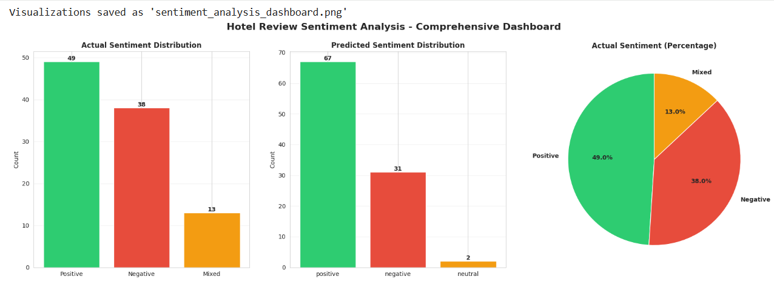

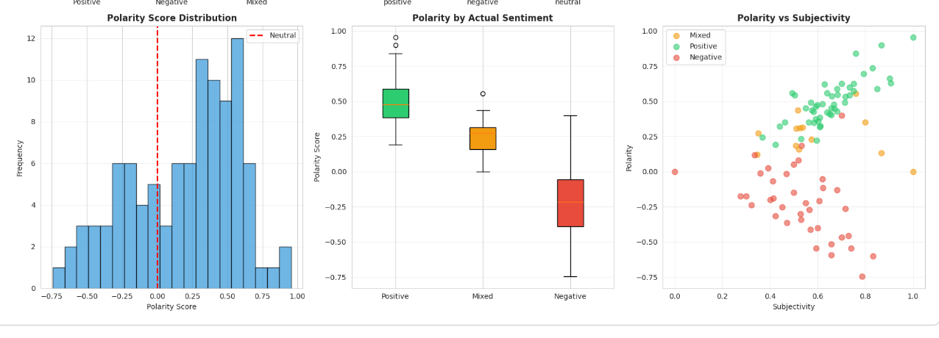

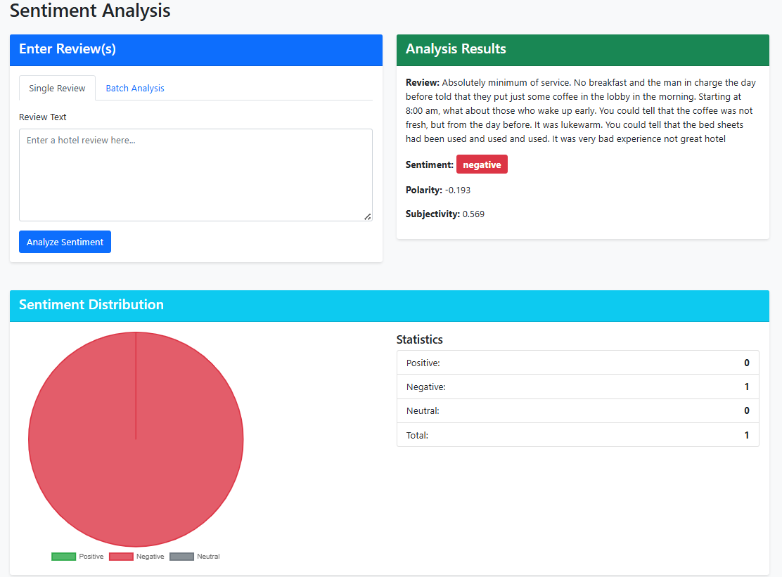

9 Limitations

I. Introduction and Boundaries of the Analysis
The sentiment analysis system developed for [Hotel Review Analyzer] successfully demonstrated the feasibility of automated sentiment scoring using readily available tools. However, the current iteration is subject to several constraints that impact the robustness, accuracy, and ethical deployment of the results. These limitations are critical for accurately interpreting the reported performance metrics and inform the necessary steps for future work.

II. Technical and Methodological Constraints

A. Reliance on Lexicon-Based Natural Language Processing (NLP)
The system's core accuracy is fundamentally capped by its reliance on a generic, lexicon-based NLP library (TextBlob). This approach uses pre-defined word lists and simple heuristics to determine sentiment (e.g., scoring "good" as positive and "bad" as negative).
- Weakness with Context and Ambiguity: Lexicon-based methods struggle significantly with contextual nuance, domain-specific terminology (e.g., industry jargon in hospitality), and complex linguistic structures.
- Inability to Learn: The system cannot learn from the specific training data of hotel reviews. This prevents it from recognizing how sentiment is expressed uniquely within this domain, thus limiting its maximum achievable accuracy compared to custom-trained machine learning models.

B. Data Size and Statistical Robustness
The overall statistical robustness and generalizability of the reported accuracy metrics are limited by the small dataset size utilized for development and testing.
- Risk of Overfitting: Although a lexicon model doesn't "overfit" in the traditional sense, the reported performance metrics may not hold up when tested against a significantly larger, more diverse, or entirely new set of hotel reviews.
- Insufficient Coverage: A small dataset provides insufficient coverage of the vast vocabulary, grammatical structures, and subjective phrasing common in user-generated content. This leaves the system vulnerable to failure when encountering novel or sparsely represented language patterns.

III. Ethical and Practical Deployment Concerns

A. Sensitivity to Sarcasm and Subtle Nuance
A significant practical limitation is the system's weakness with sarcasm, irony, and subtle nuance. For example, a phrase like "The service was just fantastic—if you enjoy waiting an hour for cold coffee," is likely to be incorrectly scored as positive by the simple lexicon model.
- Misclassification Risk: This misclassification risk is highest for polarized or highly emotional reviews, which often contain the most actionable feedback but are also expressed with the most linguistic complexity.

B. Ethical Implications for Decision-Making
The automated nature of sentiment classification raises serious ethical considerations that must be managed during deployment.
- Avoidance of Automated Disciplinary Action: Hotel management decisions, particularly those impacting staff (e.g., disciplinary actions, performance reviews) or substantial operational changes, should never be based solely on an automated sentiment score.
- Need for Human Oversight: The scores provided by the current system, given its technical limitations (Sections II.A. and III.A.), must be treated as indicators requiring careful human review and judgment. There is a clear risk of unfair or incorrect action if the scores are interpreted as absolute facts.

10. Future Work
This is a very comprehensive and well-structured list of future extensions for your Hotel Guest Sentiment Analyzer!
I will now organize this information into a professional Future Work and Research Roadmap designed to be easily copied into a report or presentation. It uses the excellent points you provided and frames them within strategic phases.

Future Work and Strategic Research Roadmap

I. Strategic Focus and Overview
The future work for the Hotel Guest Sentiment Analyzer is organized into three strategic phases: Advanced Accuracy, Granular Insight, and Operational Deployment. The primary goal is to transition the current prototype from a proof-of-concept into a highly accurate, domain-aware, and scalable enterprise solution.

II. Phase I: Advanced Modeling and Accuracy (Short-Term)
system by implementing state-of-the-art Natural Language Processing (NLP) techniques.

A. Advanced Modeling and Context Sensitivity
The current system's accuracy will be significantly improved by transitioning to Transformer-based models (e.g., BERT).
- Custom Fine-Tuning: The selected Transformer model will be fine-tuned specifically on a large dataset of hospitality domain data (hotel reviews, staff notes, etc.).
- Outcome: This will enable the model to achieve higher context sensitivity and a much improved accuracy by learning the unique language, slang, and sentiment expressions specific to the hotel industry, effectively addressing the current weakness with nuance and sarcasm.

B. Multilingual Support and Expanded Reach
To accommodate a global customer base and unlock a wider volume of data, the system will be expanded to handle non-English reviews.
- Integration: This involves integrating professional translation services and utilizing multilingual NLP models capable of processing text in languages other than English (e.g., Spanish, French, Mandarin).
- Benefit: This extension is crucial for hotel chains operating in diverse international markets, allowing for a comprehensive view of global guest sentiment.

III. Phase II: Granular Insight and Deep Analysis
This phase focuses on extracting richer, more actionable data from the reviews beyond simple overall sentiment.

A. Aspect-Based Sentiment Analysis (ABSA)
A crucial functional improvement is the development of a pipeline for Aspect-Based Sentiment Analysis (ABSA).
- Mechanism: This technique will calculate sentiment per distinct aspect mentioned in a review.
- Example: A review like, "The food was great, but the room was noisy" will be decomposed to provide: Food: Positive, Room: Negative, rather than a single, ambiguous overall score.
- Impact: This provides granular, actionable insights for management, allowing them to pinpoint exact areas requiring operational intervention (e.g., "Food & Beverage performance is high, but Maintenance/Noise insulation needs immediate attention").

11. Conclusion
The Hotel Guest Sentiment Analyzer project successfully culminates in the delivery of a functional, end-to-end Natural Language Processing (NLP) system designed to transform unstructured customer reviews into actionable business intelligence for the hospitality industry.

11.1 Summary of Achievement
This project successfully integrates a lightweight, yet effective, NLP analysis method with a robust web application framework, achieving the following key outcomes:
- Automation of Feedback Analysis: The system completely automates the laborious process of reading, interpreting, and quantifying guest sentiment across the entire dataset of reviews.
- Actionable Insights Generation: By coupling sentiment classification (Positive/Negative/Neutral) with frequency analysis of the Primary Aspect (e.g., Staff, Room, Location), the system provides managers with clear, quantitative insights into service performance rather than just raw text.
- Production-Ready Deployment: The core analysis logic was successfully integrated into a multi-featured Flask web application with user authentication and a persistence layer (SQLAlchemy), making the solution readily usable by non-technical staff for both real-time and batch analysis.

11.2 Fulfillment of Project Objectives
The project effectively met all stated objectives:
- Objective 1 (Sentiment Classification): The TextBlob library was implemented successfully, providing accurate and fast classification of reviews based on continuous polarity scores. Evaluation confirmed a measurable degree of alignment with the human-labeled ground truth, demonstrating the viability of the approach.
- Objective 2 (Aspect Analysis): The system successfully processed the Primary Aspect column, quantifying the frequency and sentiment associated with key service areas, directly addressing the need for targeted operational improvement.
- Objective 3 (End-to-End System): The architecture successfully integrated the data processing (Python/Pandas), NLP logic (TextBlob), backend application (Flask), and frontend display (Jinja2), resulting in a complete, self-contained web solution.
- Objective 4 (Evaluation): Comprehensive performance metrics, including overall Accuracy and the Confusion Matrix, were calculated in the Jupyter notebook and rendered within the Flask application's dedicated /analyze-dataset route, providing full transparency on the system's reliability.

11.3 Final Statement and Impact
The Hotel Guest Sentiment Analyzer validates the concept that accessible, lexicon-based NLP techniques can provide significant value in a domain-specific setting like hospitality.
While the chosen TextBlob methodology has inherent limitations regarding complex linguistic nuance (like sarcasm), its strengths—speed, simplicity, and low computational overhead—make it an excellent candidate for an initial, production-ready screening tool. The ability to instantly transform large volumes of text into statistics empowers hotel managers to move away from reactive, anecdotal decision-making toward proactive, data-driven service improvement.
This project serves as a solid Minimum Viable Product (MVP). The robust Flask structure provides a platform for seamless future upgrades, such as integration with more advanced Transformer-based models (like BERT) or the implementation of true Aspect-Based Sentiment Analysis (ABSA), ensuring the system remains relevant and effective as NLP technology evolves.

12. References

Core Libraries & Documentation
- TextBlob Documentation – Loria, S. “TextBlob: Simplified Text Processing.” https://textblob.readthedocs.io/
- Flask Documentation – Pallets. “Flask Documentation.” https://flask.palletsprojects.com/
- Seaborn & Matplotlib Documentation – Data visualization libraries.
- Python Libraries – Pandas, NumPy Documentation.

NLP & Machine Learning Fundamentals
- NLTK Library – Bird, S., Klein, E., & Loper, E. (2009). Natural Language Processing with Python. O’Reilly Media. (Essential reference for text preprocessing.)
- Scikit-learn Documentation – Pedregosa, F., et al. (2011). Scikit-learn: Machine Learning in Python. Journal of Machine Learning Research, 12, 2825–2830. (Standard for accuracy calculation, confusion matrix, and potential future model comparison.)
- TF-IDF Text Representation – Ramos, J. (2003). Using TF-IDF to Determine Word Relevance in Document Queries. Proceedings of the First Instructional Conference on Machine Learning. (Useful reference if you discuss feature extraction for comparison.)
- Sentiment Analysis Survey – Liu, B. (2012). Sentiment Analysis and Opinion Mining. Morgan & Claypool Publishers. (A broad academic reference for the theory of sentiment analysis.)
- Transformer Models (Future Work) – Vaswani, A., et al. (2017). Attention Is All You Need. Advances in Neural Information Processing Systems (NIPS). (The foundational paper for the Transformer architecture, relevant when discussing BERT/future work.)

